**HR Application Integrates with Payroll & Other Tools**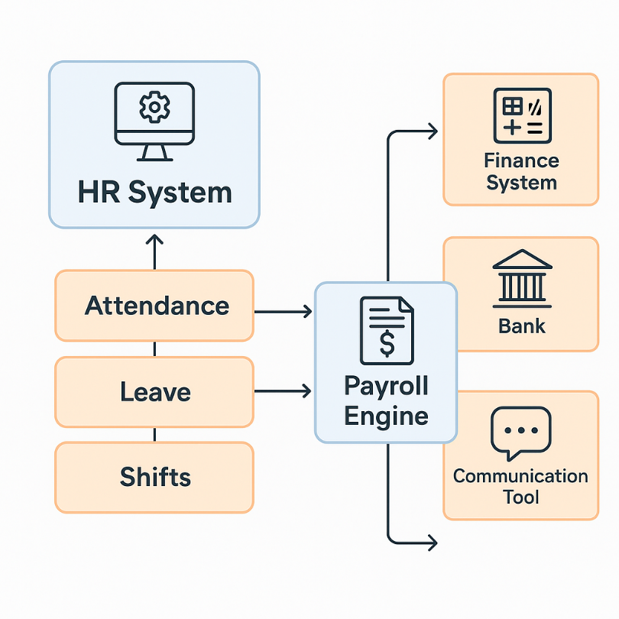

Here the workflow is when tracking the attendance of the employees & based on that has to calculate their payee. After that generate the payslip and notifzzy about that using slack or Microsoft teams to HR.

**For a company in Sri Lanka for 50 employees**

How to create a payroll engines:

* Create a own engine
* Third part tool

For Sri Lanka: myPayroll.lk, BISTEC Payroll,hSeind HRMenterprise,Microimage HCM(Sri Lanka)

For Global :QuickBooks payroll, Zoho people + Creater,Guesto,Deel/Remote.com

By considering those payroll systems are not directly give the access to the custom payroll logic as well as not supporting to the Sri Lankan EPF/ETF.Those need to implement middle ware .

What is middleware:

* Fetch attendances, leave and bonus data from HR modules.
* Apply custom logic.
* Locks payroll after HR approval
* Generates payslips
* Enable full automation.

Considering the Third party tools + middlware

|  |  |  |  |  |
| --- | --- | --- | --- | --- |
| Tool | API support | Can pull attendance via Middlware | Notes |  |
| Zoho People + Creator | Yes | Yes | Best fit. Can fetch attendance via API and use in payroll logic. |  |
| QuickBooks Payroll | Limited | Partially | You calculate salary in middleware, then push the result. |  |
| Microimage HCM (Sri Lanka) | Enterprise only | Yes | Must pay for integration or API access. |  |
| hSenid HRMenterprise | Enterprise only | Yes | Works only in large-scale setups. |  |
| myPayroll.lk | No API | No | Cannot integrate or pull attendance data. |  |
| Deel/ Remote.com | Yes | No | No support for attendance or shift logic. |  |
| Gusto (US only) | Yes | No | No attendance data handling. |  |

By considering those it is the best solution :**Zoho payroll + creator**

[ TalentNest HRMS DB ]

→ Attendance, leave, bonuses

⬇ Middleware (Node.js)

→ Applies salary logic

→ Calculates EPF/ETF, OT

⬇ Push to Zoho Creator API

→ Store & display in Creator

→ Generate payslips via Zoho Writer

**Salary Logic**

Net Salary =

(Basic Salary / Work Days) × Present Days

+ OT Pay

+ Bonuses

- No-Pay Deductions

- Employee EPF (8%)

- Loan/Other Deductions

* But the cost for Zoho + creater per month may be 70$

**2nd option: Create own payroll engine:**

**Advantages from create own engine**

100% control over logic & design

Local compliance (EPF/ETF/OT/bonuses)

Custom UI, PDF formats, automation

In my point of view creating a payroll engine using Zoho+creator may be the best solution:

When creating own engine fault with:::Accuracy in testing

::: Payslip formatting

:::Payslip formatting

After completing all the steps can be applied api for informing about this to HR by using slack or email.